**Website Report**

**(I’ll attach my initial project proposal with this report as I’m unsure if this is also needed in this upload)**

All images are stock photos, any included in the images folder are either of my own creation (trademic logo) or using the royalty free stock images from Microsoft Word. The only exception is the harmonica photo which I used the URL from Pinterest as to demonstrate flexibility of using image sources.

All the audio used is also my own from playing trad music and because of the nature of the music, composers and copyright are traditionally irrelevant due to the Irish songs being largely passed down by ear and not by notes or written means. The authors of the music are either unknown or long deceased to which there is little need to reference.

The HTML and CSS used was either covered in class or learned from W3 Schools.

Each page of this website will have a black, white, and green colour scheme with contact details for tutors or site managers on each one except for the home page and online pub.

Each instrument page will contain audio snippets of varying quality due to most if not all recordings will be recorded on my phone.

Instrument pages will also each contain a brief description of the instrument they have with places of interest for each such as John McKenna’s house for the flute tab or pubs for sessions.

The overall aim of this website is to encourage learning trad music but also to bring the trad community together, I have big plans for the online pub regarding online sessions that will listen and make sure all players are playing on the same note at the same time, essentially fixing the problems of lagging audio but I’m unsure as to my coding experience by that time and whether I’d be able to implement it.

Here is a sample image of what I’m looking to achieve for the final design.

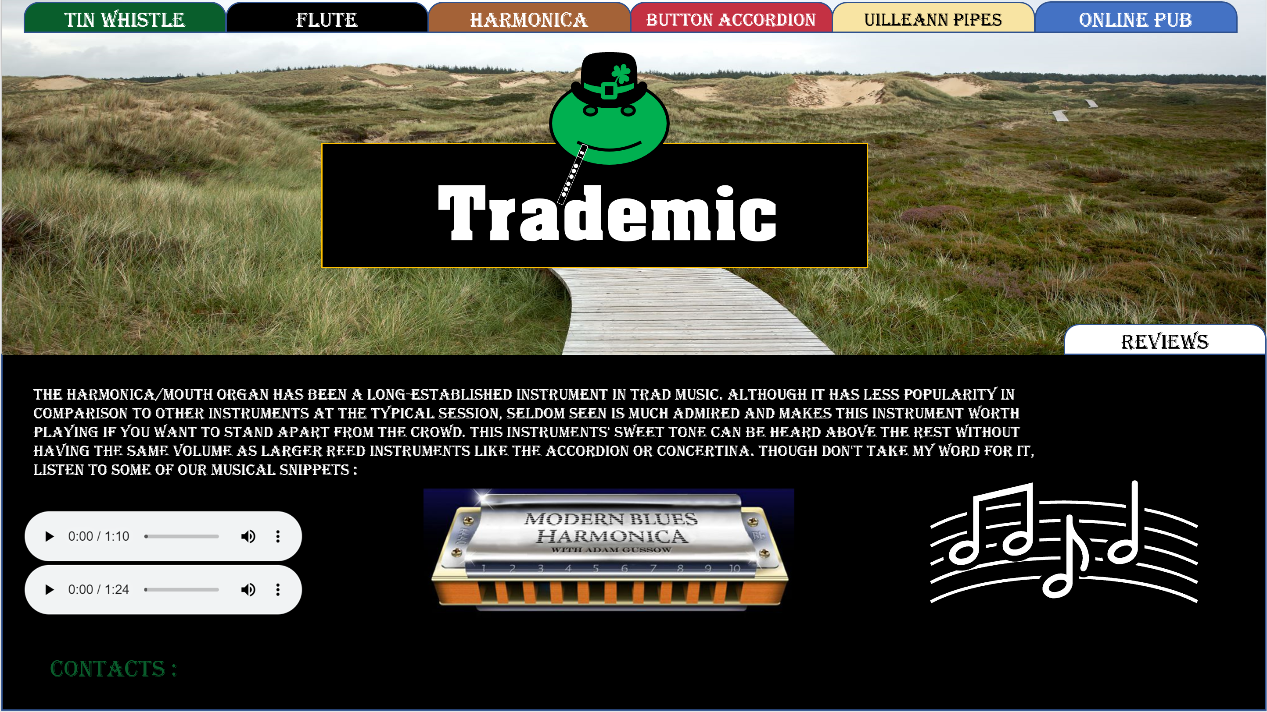

Github URL : https://github.com/CCp0/Website_Project-Trademic